**LAB 01**

**Creating Conda Environment:**

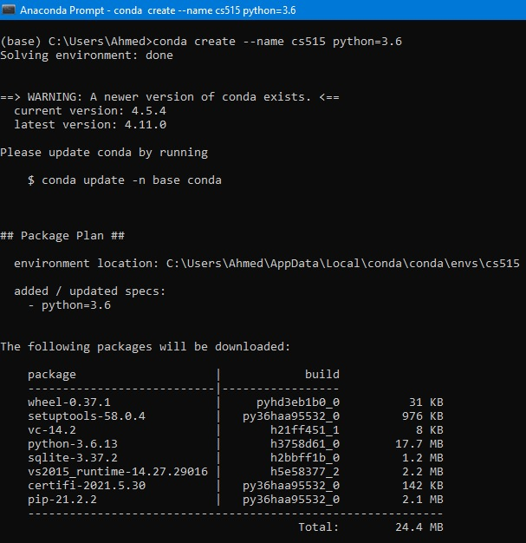

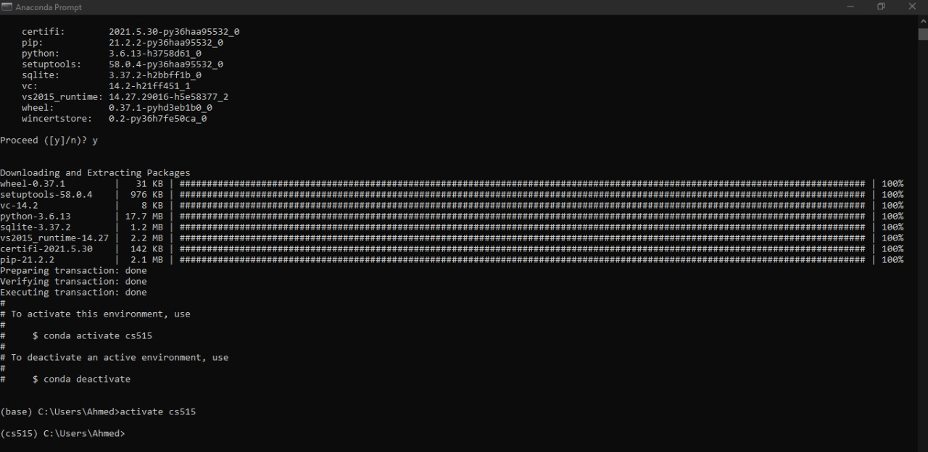

**Entering the Environment:**



**Invoking the Interpreter:**

**Operators and Strings:**

